

**Faculty of engineering - Shoubra**

**Benha University**

**Research Article**

in fulfillment of the requirements of

|  |  |
| --- | --- |
| **Department** | **Engineering Mathematics and Physics** |
| **Division** | **-------------** |
| **Academic Year** | **Preparatory year 2019-2020** |
| **Course name** | **Computer** |
| **Course code** | **ECE001** |

**Title: -**

**Building a website on artificial intelligence**

By:

|  |  |  |  |
| --- | --- | --- | --- |
|  | Name | Edu mail | B.N |
| 1 | Mohamed Mamdouh | muhammed195895@feng  .bu.edu.eg | 803 |

**Approved by:**

|  |  |
| --- | --- |
| Examiners committee | Signature |
| Dr. Ahmed Bayoumi |  |
| Dr. Shady Elmashed |  |
| Dr. Abdelhamid Attaby |  |

**Name** : Mohamed Mamdouh Salah Ahmed Morsy

**B.N /** 803

**Date :** 26/5/2020

**Topic :** Artificial Intelligence

**Github link :**

**Github pages :**

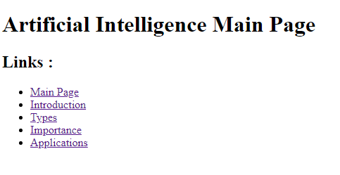

**Source code :**

